# Novel Recommendation System

## Chapter 1: Introduction

In the realm of literature, novels have long captivated readers with their immersive narratives and diverse genres. With the advent of the digital age, novels have found a new platform in the form of web novels, offering a convenient and accessible way to engage with literary works. To enhance the reading experience and guide users towards their desired literary preferences, novel recommendation systems play a crucial role. These systems employ sophisticated algorithms to analyze user behavior, preferences, and novel characteristics, providing personalized recommendations that cater to individual tastes and interests.

## Chapter 2: Problem Statement

The vast expanse of available novels poses a challenge for readers in discovering titles that align with their preferences. Traditional recommendation approaches may overlook subtle nuances in user interests, leading to recommendations that fail to fully resonate with users. Moreover, the dynamic nature of reader preferences and the continuous influx of new novels demand a recommendation system that can adapt and evolve over time.

## Chapter 3: Objectives

The proposed research aims to address the limitations of existing novel recommendation systems by developing a novel recommendation system that:

* Accurately analyzes user preferences and interests, capturing both explicit and implicit signals
* Effectively utilizes novel characteristics, including genre, plot, themes, and writing style, to identify meaningful patterns
* Employs robust machine learning algorithms to adapt to evolving user preferences and the introduction of new novels
* Provides personalized recommendations that enhance reader engagement and satisfaction

## Chapter 4: Methodology

This proposal outlines a novel recommendation system employing the Spiral Methodology for continuous improvement and user-centric development. The system will be built in iterative cycles, each with specific objectives and deliverables.

The initial cycle will focus on building a basic prototype, gathering user feedback, and identifying potential risks. Subsequent cycles will address these risks, integrate new features based on feedback, and continuously improve the recommendation algorithm and user interface.

Within each cycle, key activities include planning, design, implementation, verification, evaluation, and risk management. Continuous feedback loops ensure the system evolves to meet user needs and preferences, leading to increased engagement, satisfaction, and platform adoption.

Here are the key benefits of using the Spiral Methodology:

Early Risk Mitigation: Potential problems are identified and addressed early, reducing development risks.

User-Centered Development: Continuous feedback ensures the system aligns with user needs and preferences.

Incremental Improvement: Features are added and improved gradually, allowing for easier testing and adaptation.

Reduced Development Costs: Early risk mitigation and iterative development optimize resource allocation and cost savings.

Improved System Performance: Continuous feedback loops lead to ongoing improvement in recommendation accuracy and user experience.

By utilizing the Spiral Methodology, this novel recommendation system will deliver personalized reading experiences for users, adapt to evolving needs, and remain at the forefront of technological advancements. This will ultimately contribute to increased user engagement, satisfaction, and platform adoption.

### a. Requirement Identification

i. Study of existing systems: A comprehensive review of existing novel recommendation systems will be conducted, examining their strengths, limitations, and underlying techniques. This analysis will inform the design and development of our proposed system.

ii. Requirement Collection: User surveys and interviews will be conducted to gather insights into user preferences, expectations, and pain points with regard to novel recommendations. This feedback will guide the formulation of user-centric requirements for the system.

### b. Feasibility Study

i. Technical: The feasibility of developing the proposed novel recommendation system will be assessed in terms of the availability of appropriate technologies, software tools, and expertise.

ii. Operational: The operational feasibility will consider the resources required to implement and maintain the system, including personnel, infrastructure, and operational costs.

iii. Economic: The economic feasibility will evaluate the potential benefits of the system, such as increased user engagement, improved customer satisfaction, and potential revenue generation from personalized advertising.

### c. High Level Design of System

System Flow Chart

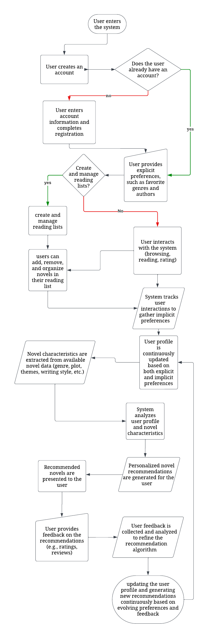

### Methodology of the Proposed System

The proposed novel recommendation system will employ a hybrid approach that combines collaborative filtering, content-based filtering, and deep learning techniques. Collaborative filtering will identify similar users and recommend novels that they have enjoyed. Content-based filtering will match novels to users based on their similarity to novels the user has already liked. Deep learning will be used to extract complex patterns from user behavior and novel characteristics, enabling more accurate and personalized recommendations.

### Working Mechanism of Proposed System

1. User interacts with the system, providing explicit preferences and implicit signals through their browsing behavior and ratings.
2. User profile is constructed and updated, capturing user preferences, interests, and reading history.
3. Novel data is collected and processed to extract relevant features, including genre, plot, themes, writing style, and character archetypes.
4. User profile and novel representations are fed into the recommendation algorithm.
5. Recommendation algorithm utilizes machine learning techniques to generate personalized novel recommendations.
6. Recommended novels are presented to the user in an engaging and user-friendly manner.
7. User feedback is collected and analyzed to refine the recommendation algorithm and improve the overall system performance.

## Chapter 5: Gantt Chart

[Insert Gantt Chart showing the project timeline]

## Chapter 6: Expected Outcome

The proposed novel recommendation system is expected to achieve the following outcomes:

* Enhanced user engagement and satisfaction with personalized novel recommendations
* Increased discovery of new and relevant novels that align with user preferences
* Improved understanding of user preferences and reading behavior through data analysis
* Potential revenue generation from targeted advertising based on user interests

## Chapter 7: References

[Insert list of relevant academic references]